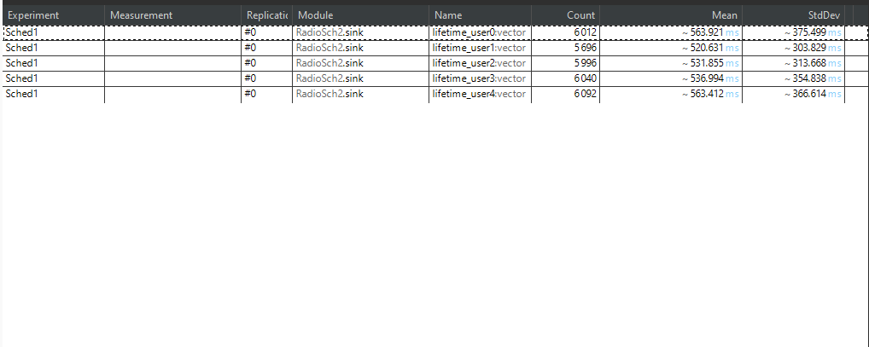
Graphics and Values for Network Load 30%
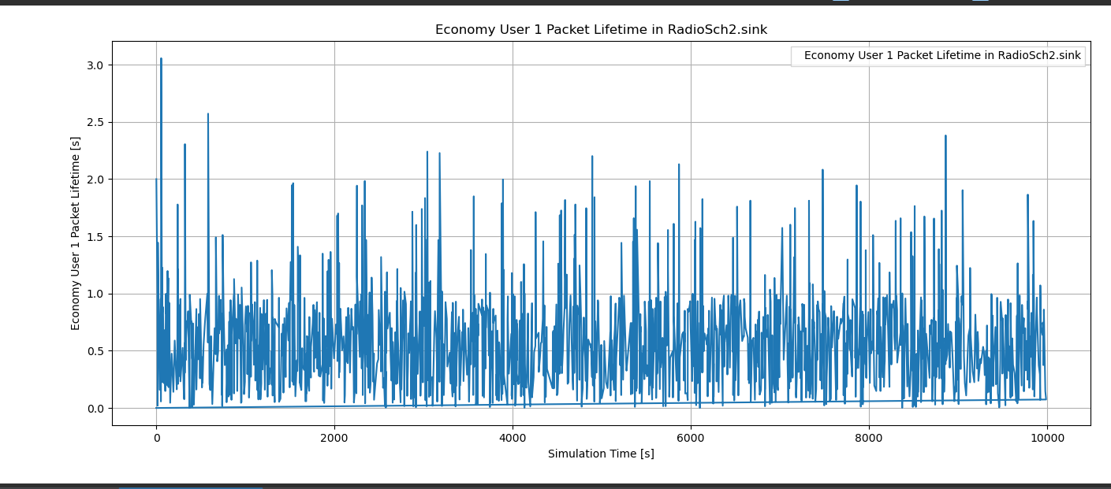

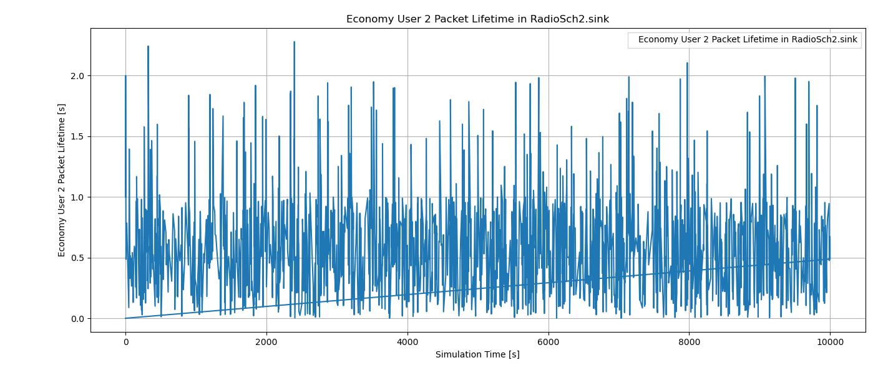
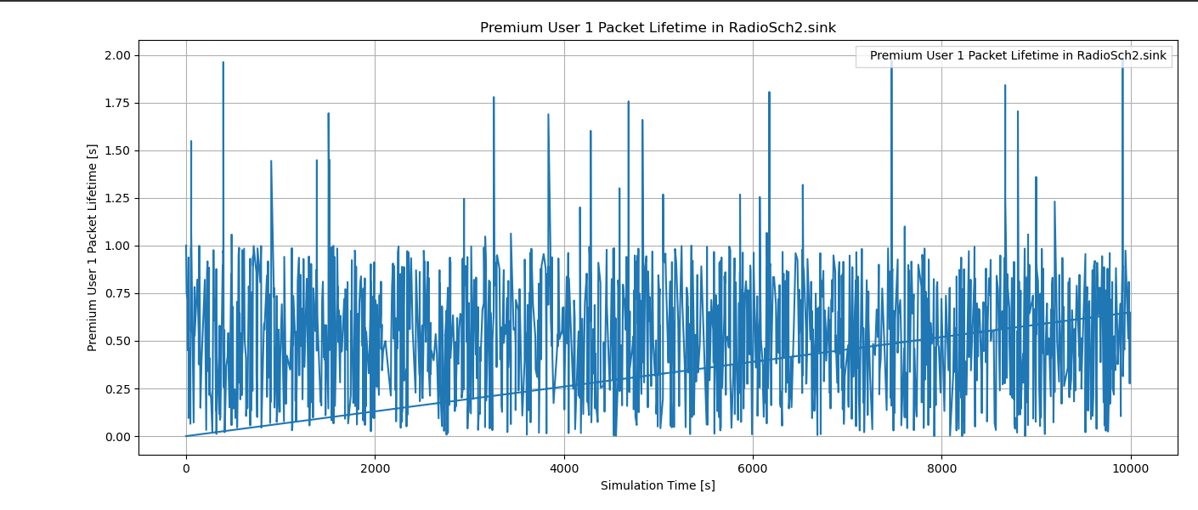

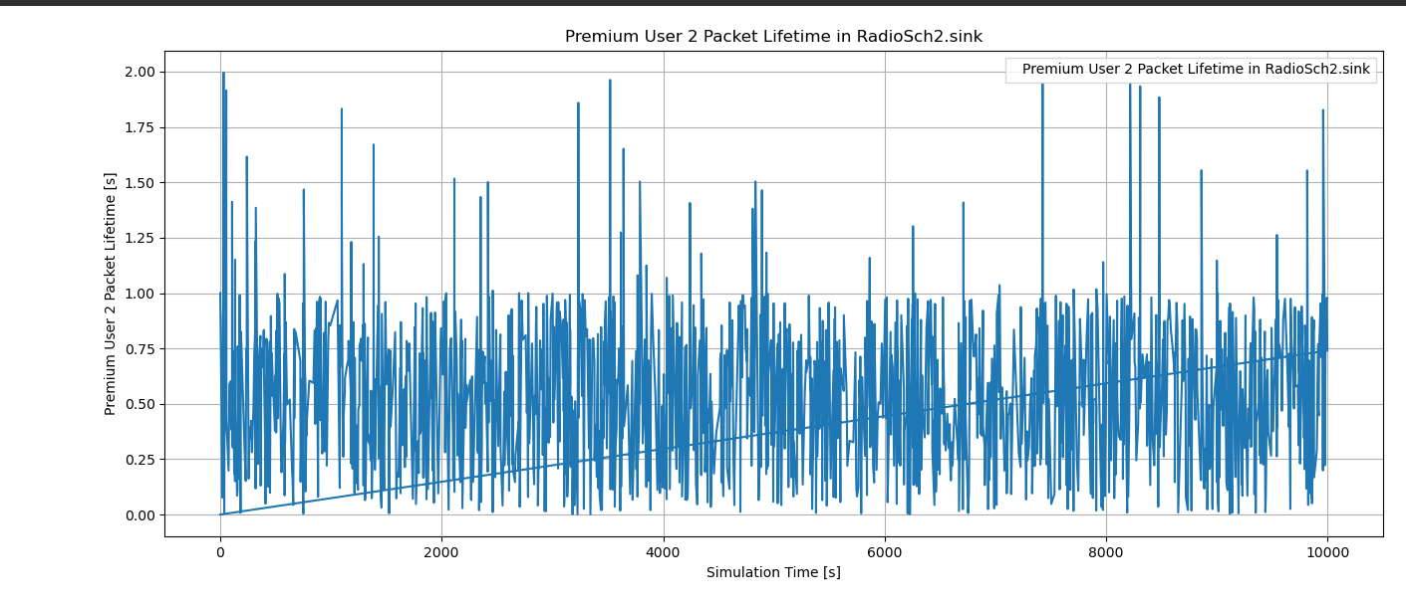

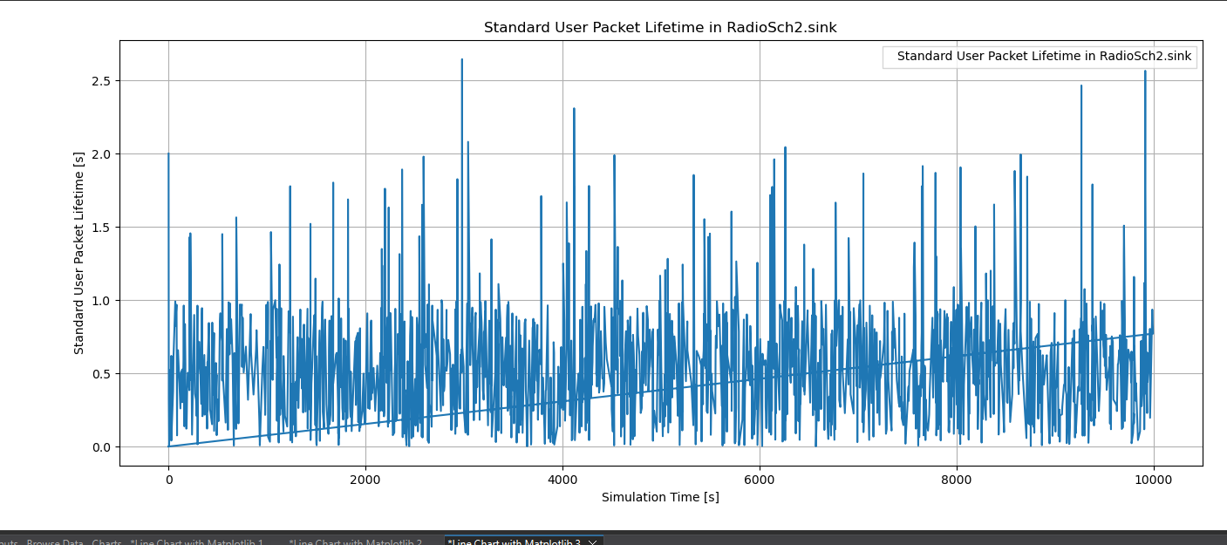

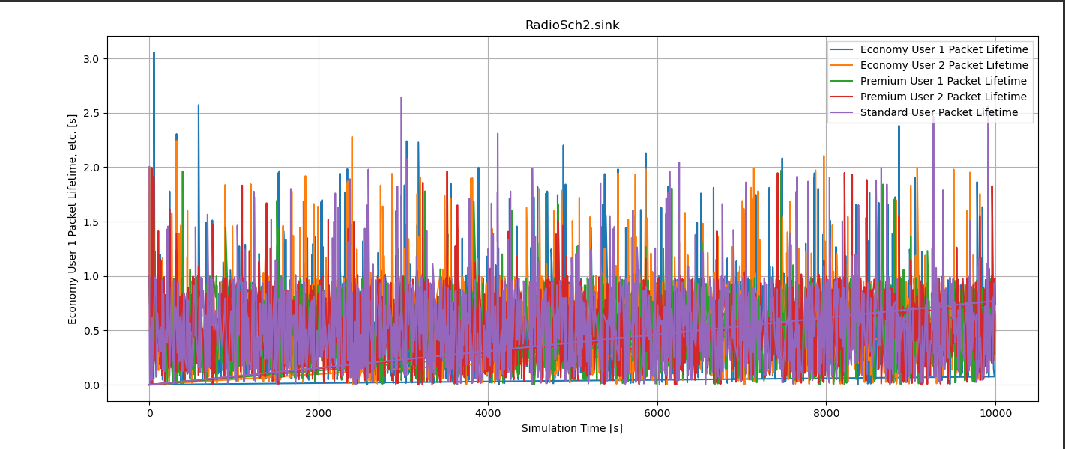

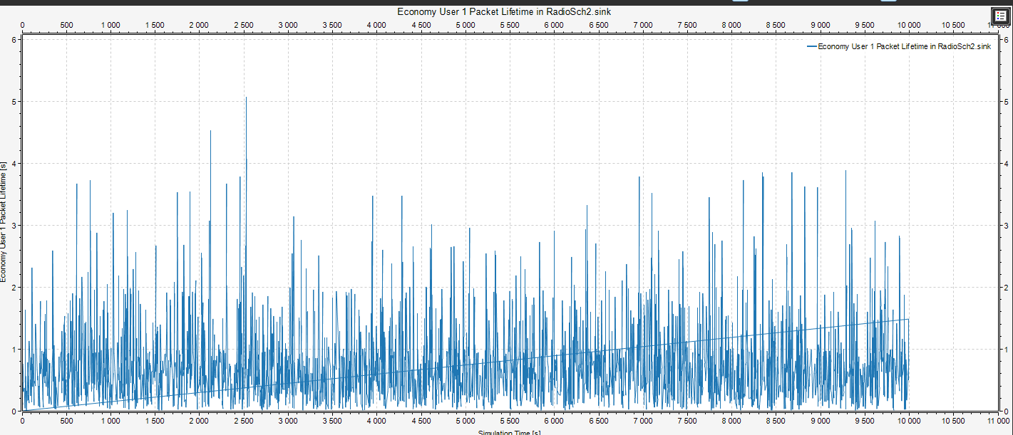
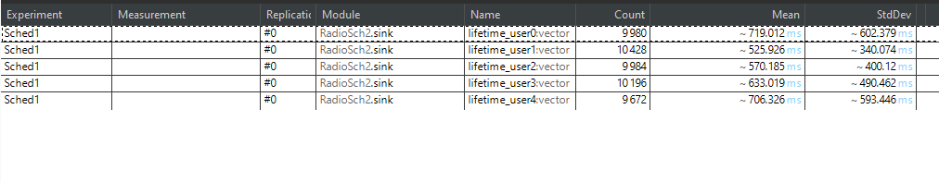
Graphics for Network Load 50%

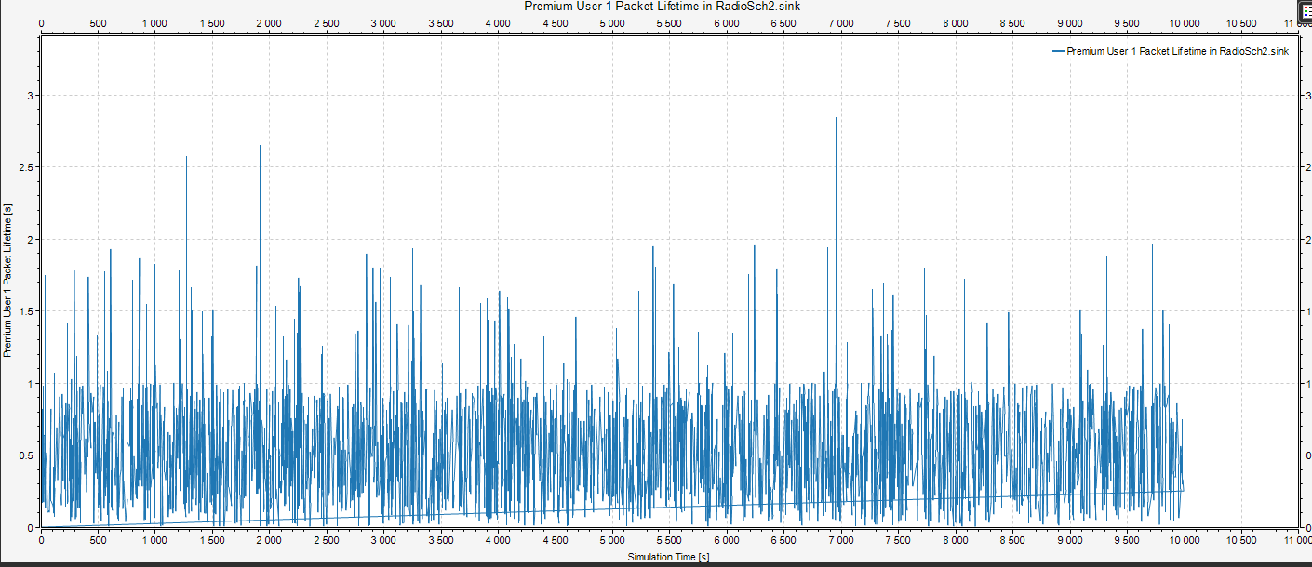
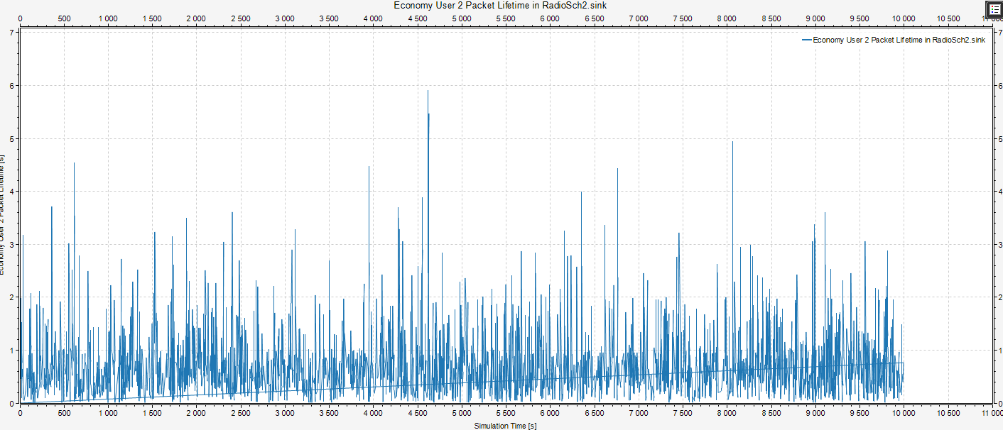

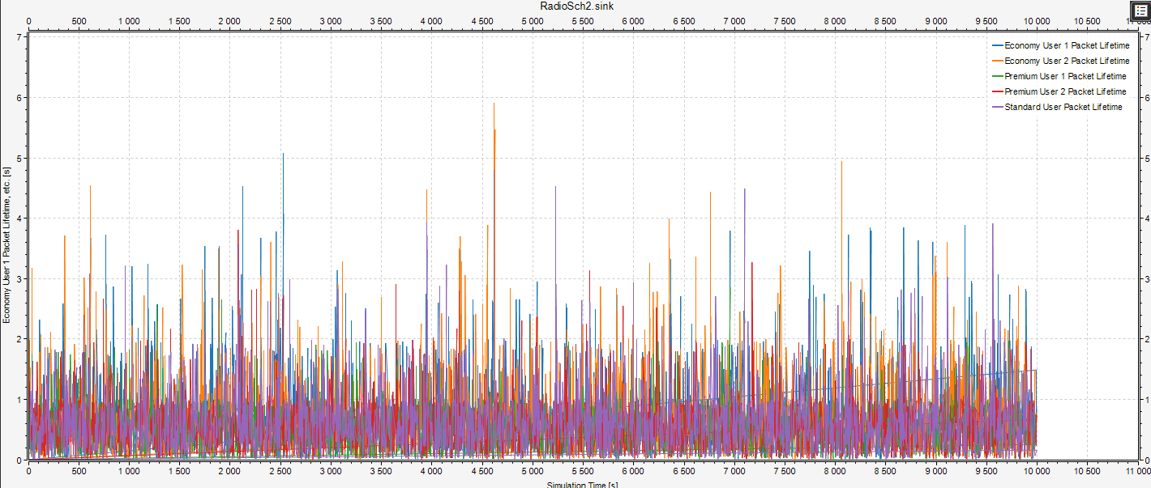
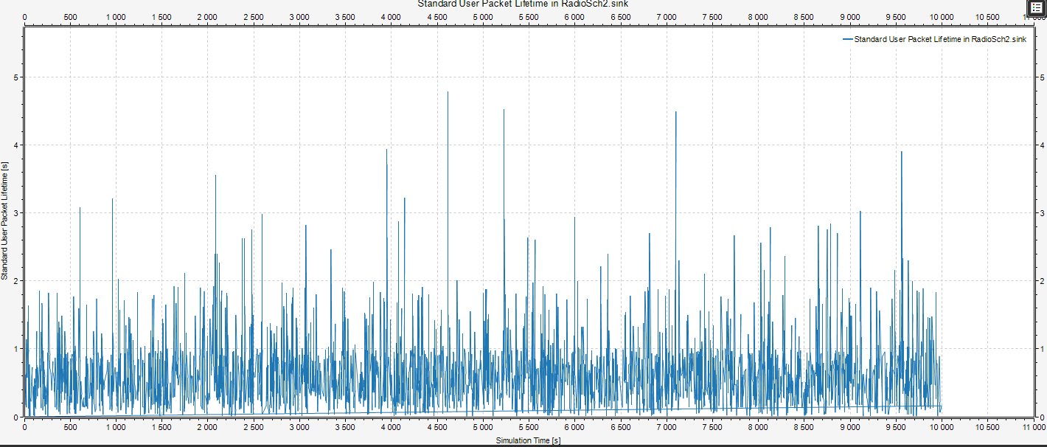
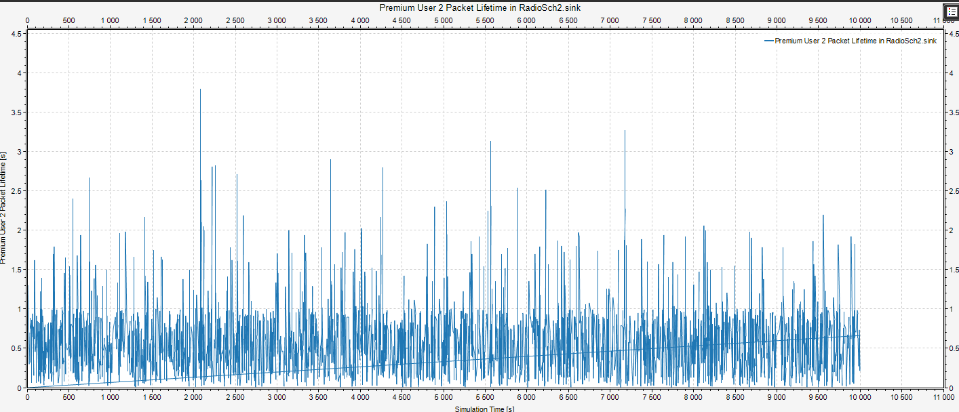

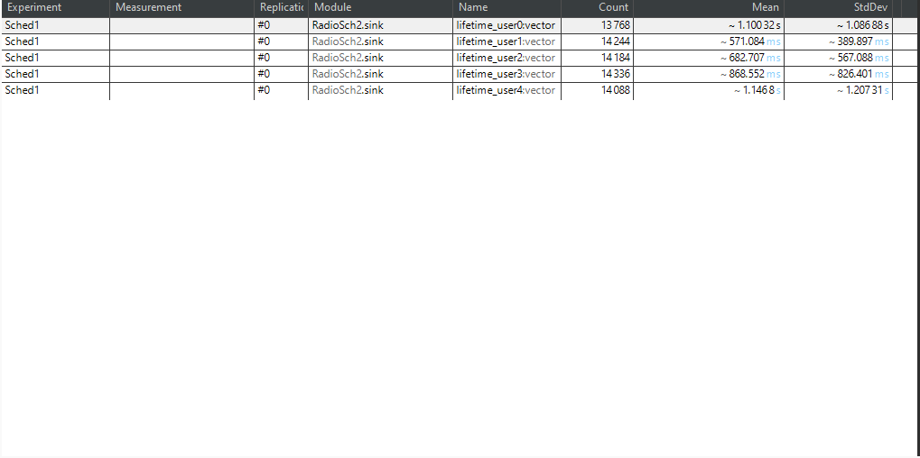
Graphics for Network Load at 70%

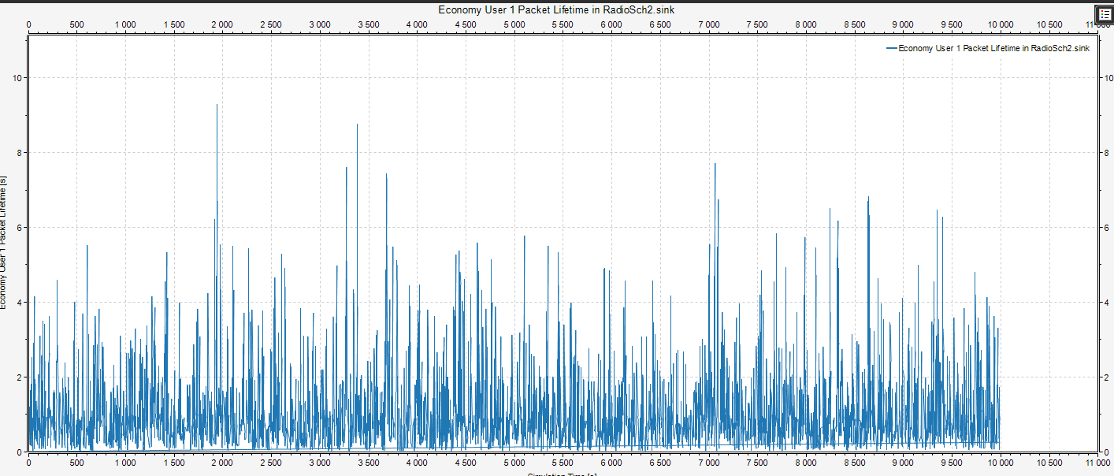
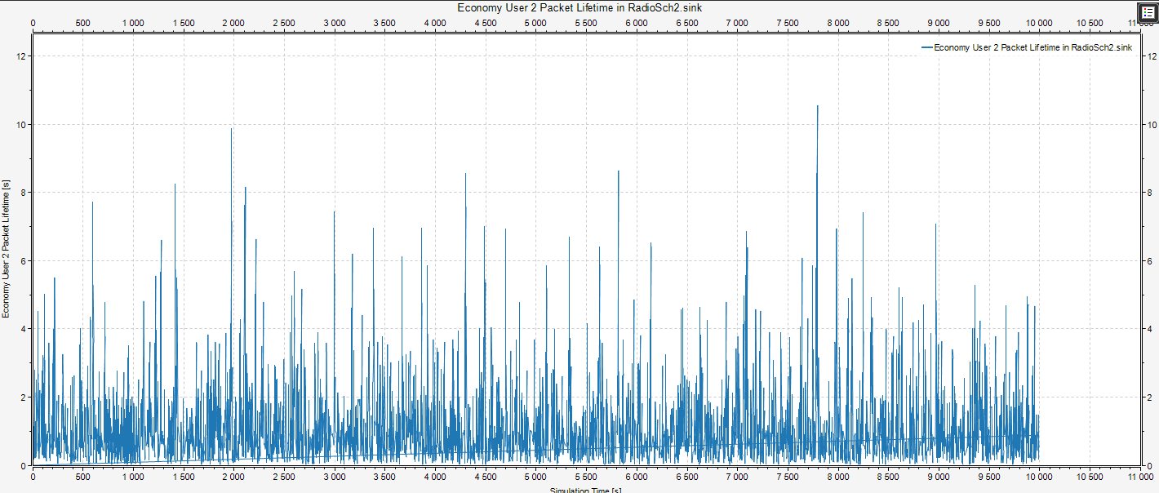
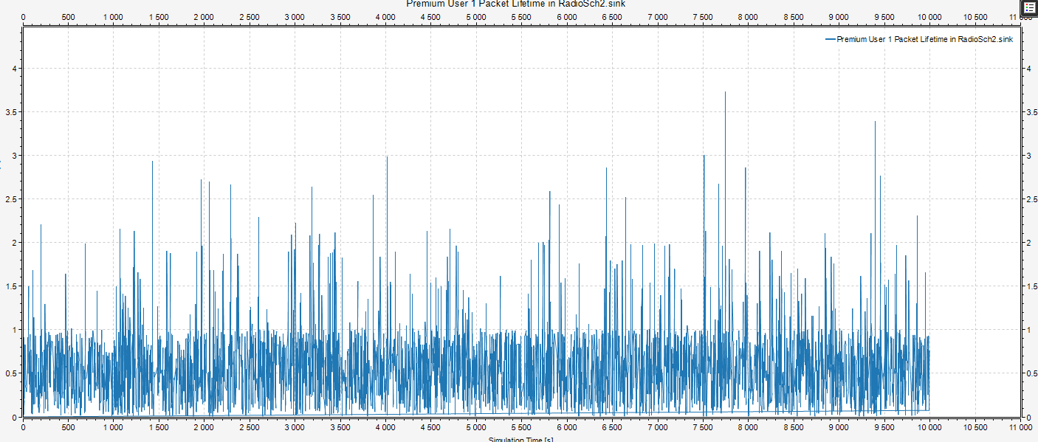
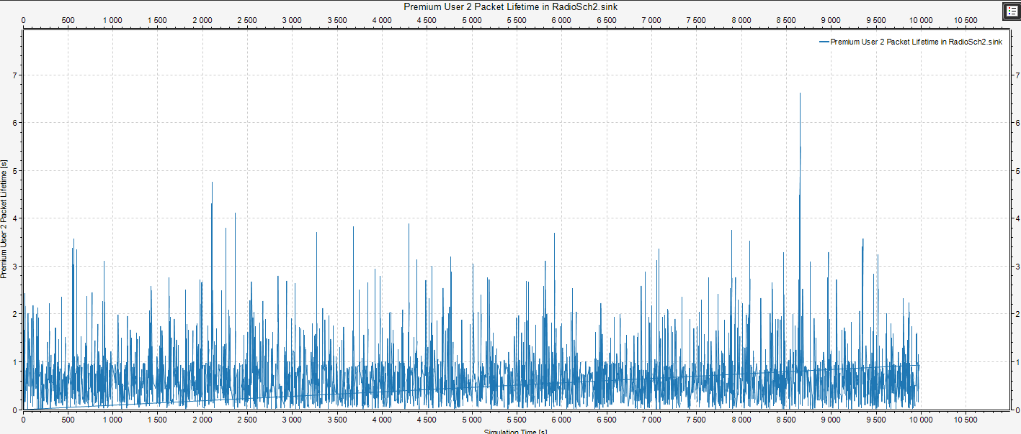
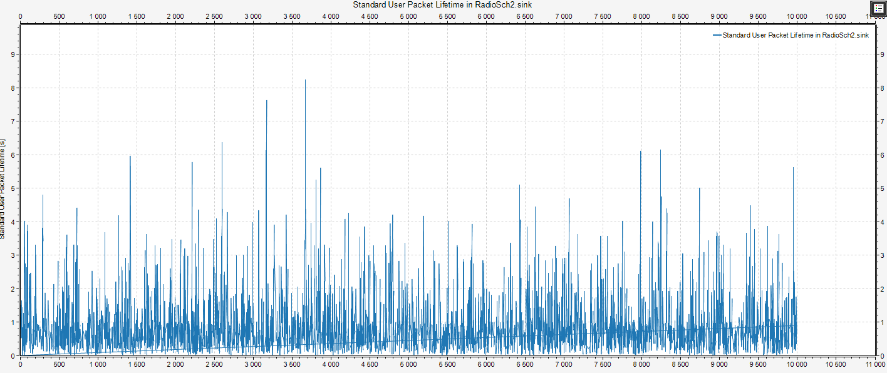

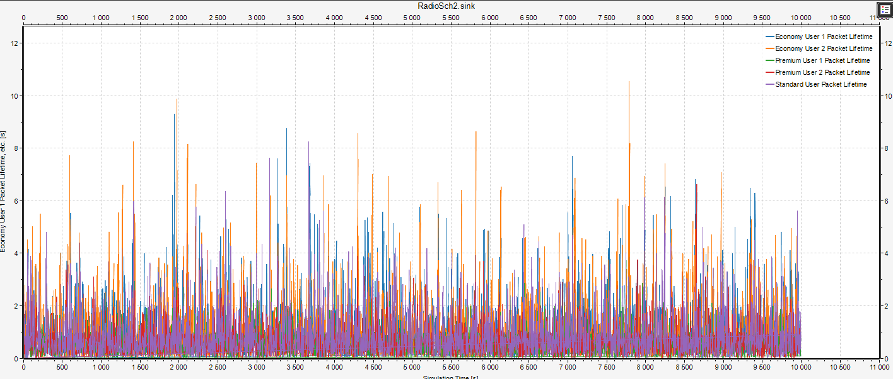

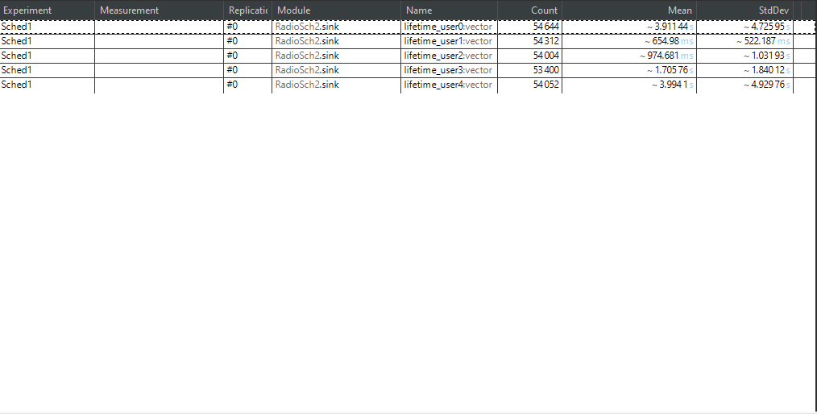
Graphics for Network Load 90%

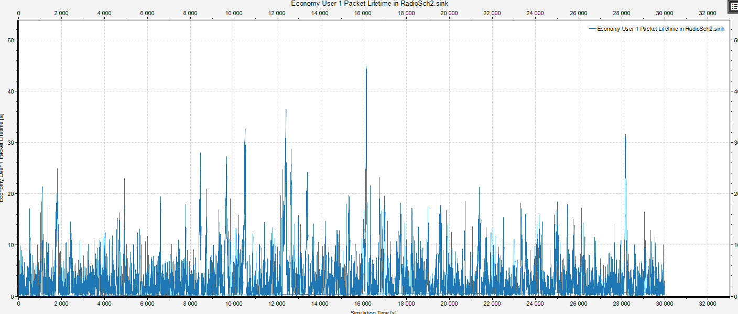

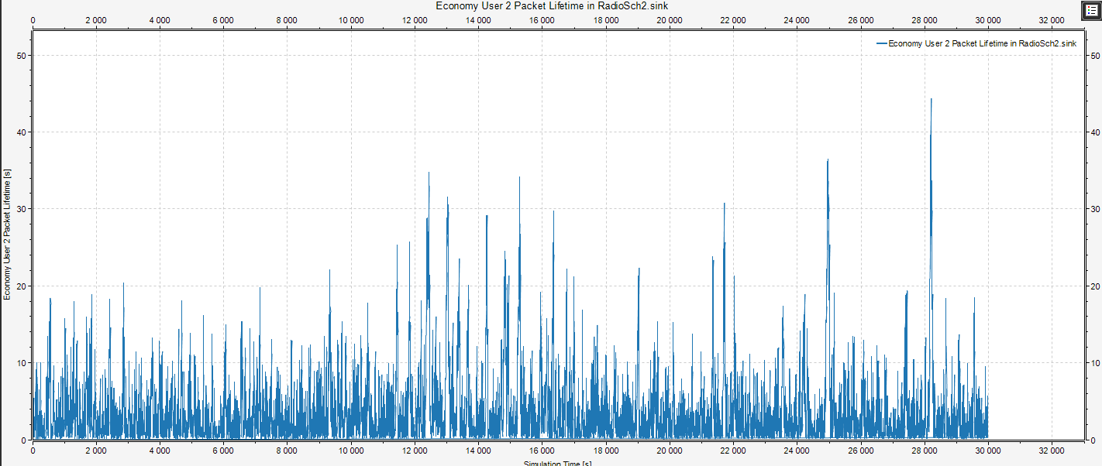

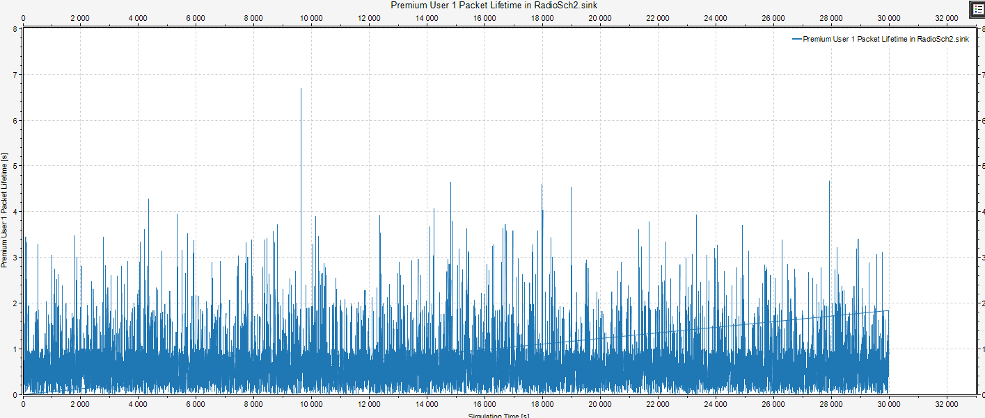
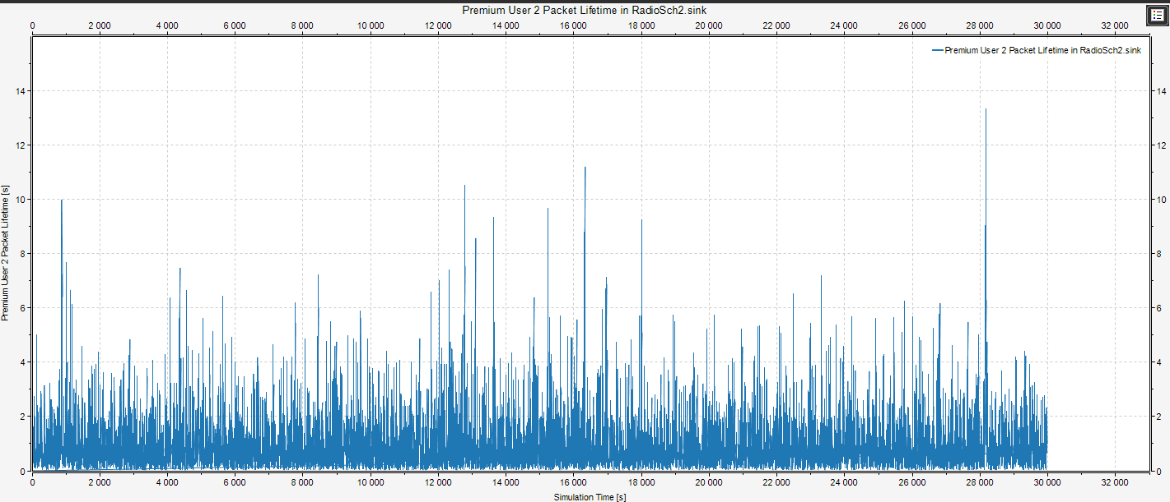

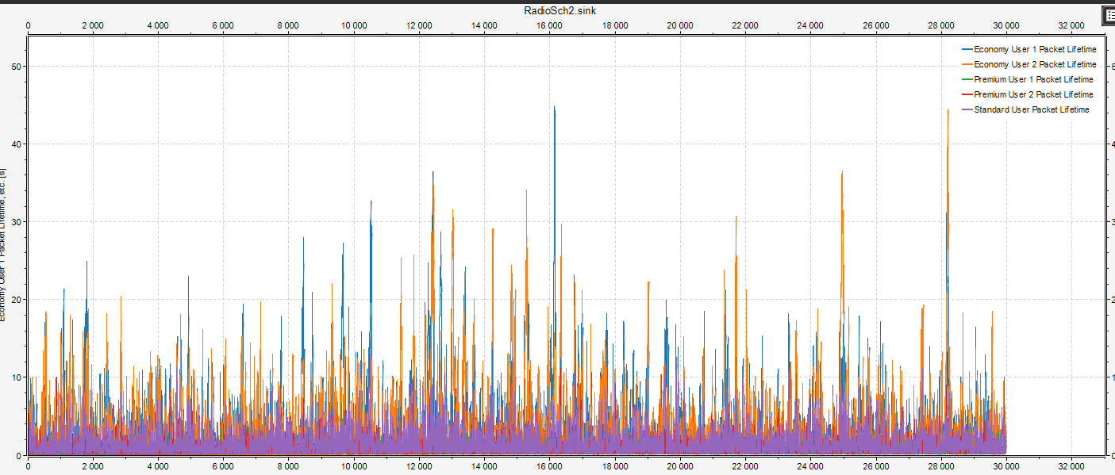
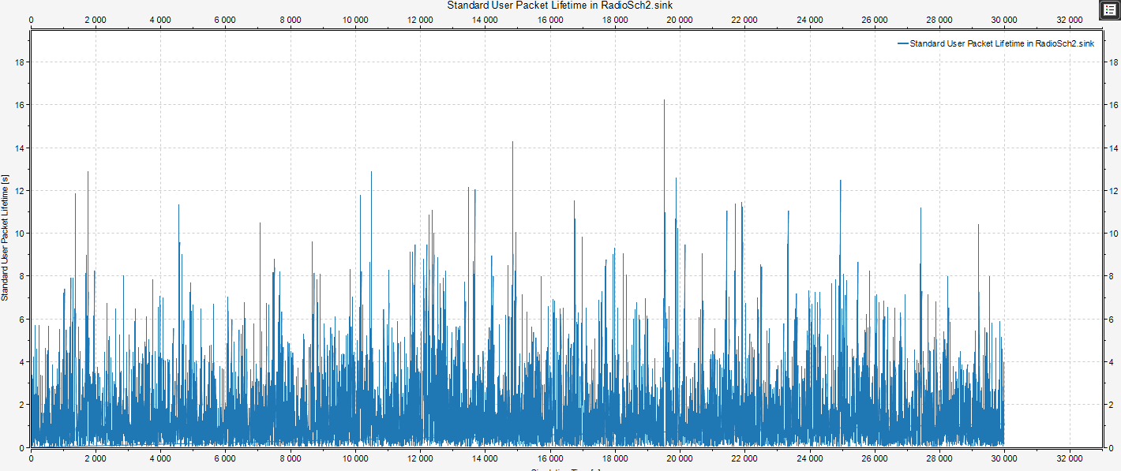

Values used for each user’s qlq:
User[0]=20
User[1]=100
User[2]=80
User[3]=50
User[4]=20

Fuzzy Logic Results

- The values used for each user’s qlq are the same as the one used for the nonfuzzy example
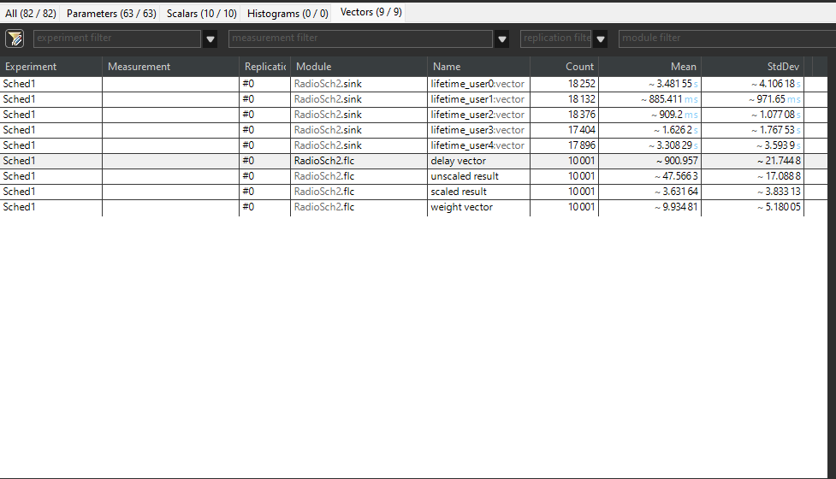
- The network load used here is 90%

- The following is the graphic for the Delay Vector. It was supposed not to surpass the value 1100 and as it can be seen from the graph it doesn’t, later in the simulation even stabilizing

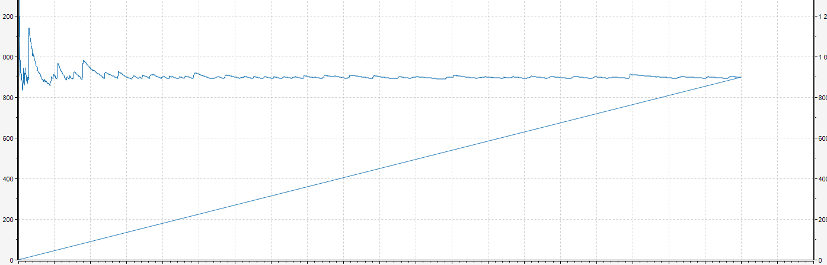

- What can be observed from the comparison between the results using a FLC and the ones not using a FLC is that the ones using a FLC are more stable, the users with high priority not having a big difference when it comes to the mean in the case of the FLC use.
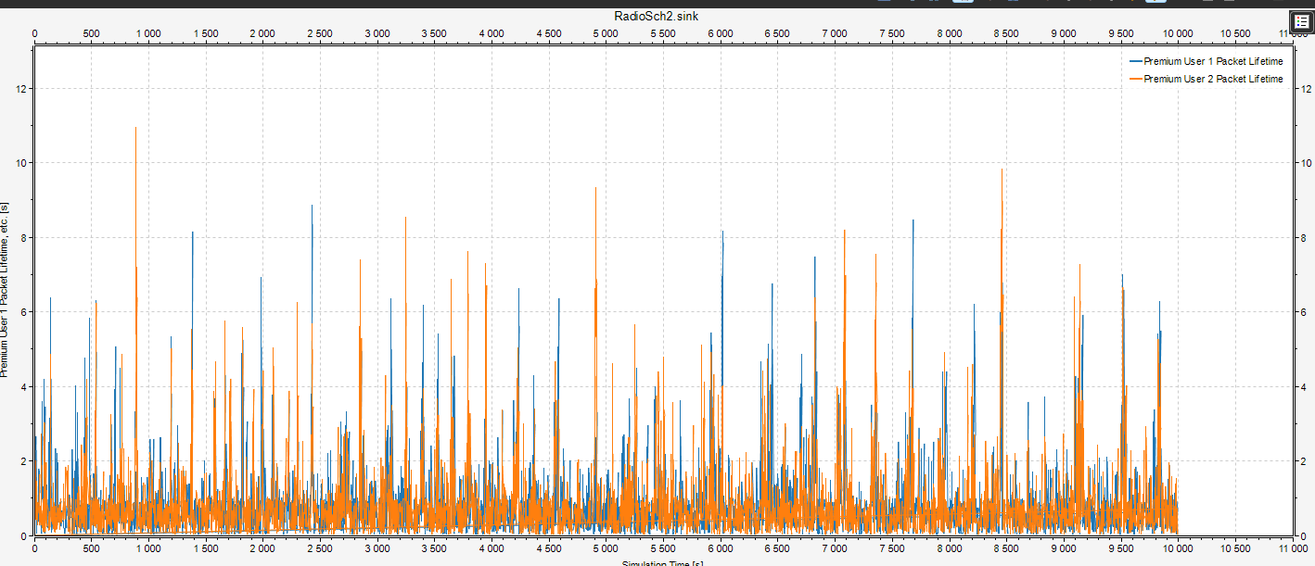

Rules used for the fuzzy logic controller
- First set of rules
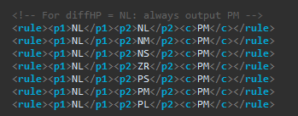

The reasoning for this set is that even though HP might be a little bellow the desired target, we want to increase gradually to the desired level, thus we output PM.
- Second and third set of rules
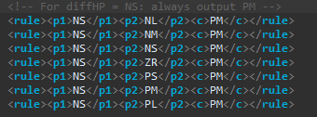
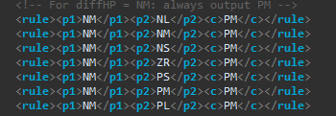

The reasoning for these sets of rules is the same as for the first one, we want to increase the W_HP gradually.

- Fourth set of rules
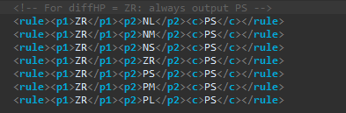

For this set, the reasoning is that we are closer and closer to the desired values, thus we must increase it slowly in order not to make any undesired changes that may unoptimized the process.

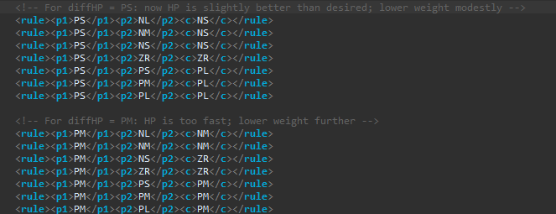
- Fifth and sixth set of rules

For these set of rules we simply want to adjust accordingly to how good the W_HP is. Thus depending on how farther it is from the desire value, we make sure to lower it down accordingly.

- Seventh set of rules
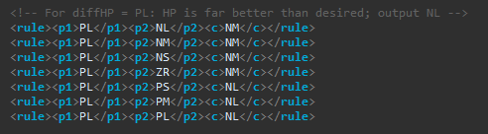
Here we lower it at first little by little and as it gets farther from the desired value we lower it largely.

Conclusion
Based on my personal observations, I consider that using the fuzzy logic we help stabilize the whole process of communication, while also prioritizing the high priority users accordingly. It can be further added that fuzzy logic is very useful when it comes to transferring huge chunks of data.

